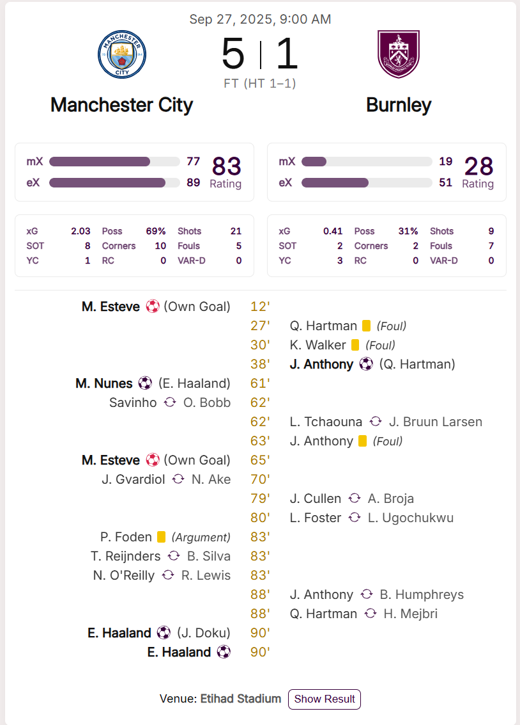
2 own goals – too much credit for MC?
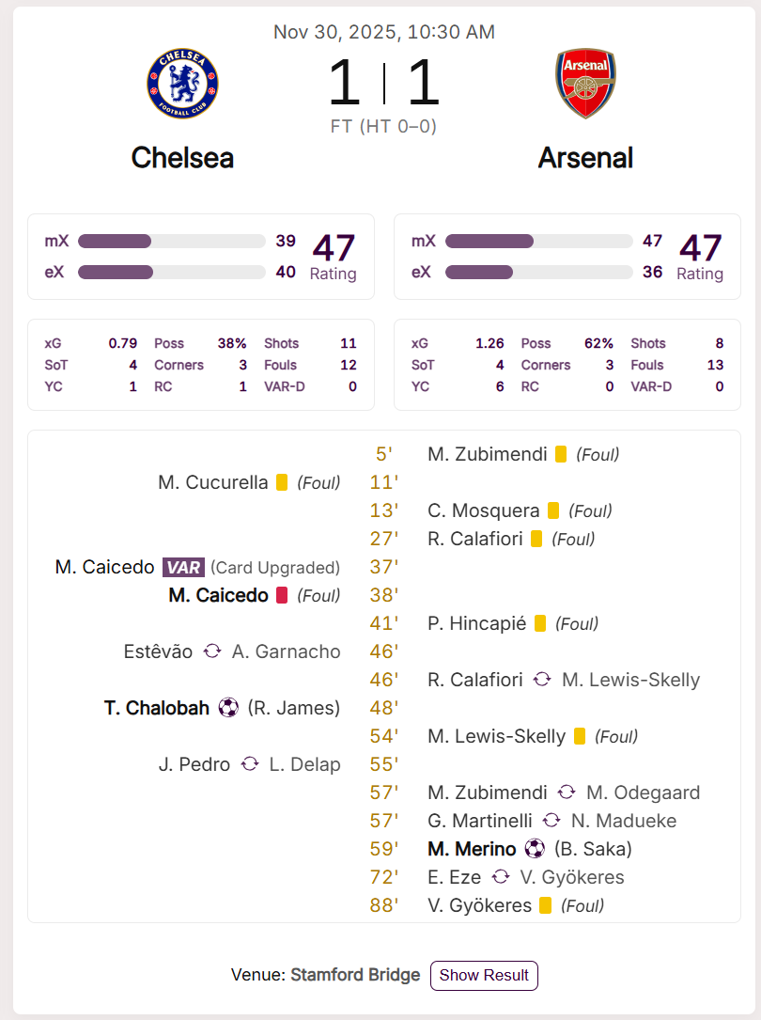
Scored and took the lead with 10 men
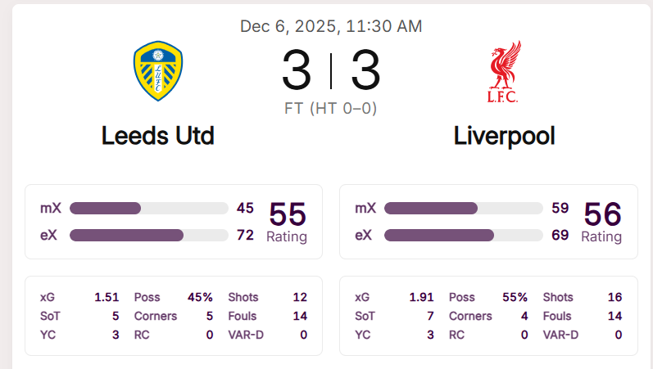
Leeds should have better credit for being the lowly side v mighty Liverpool
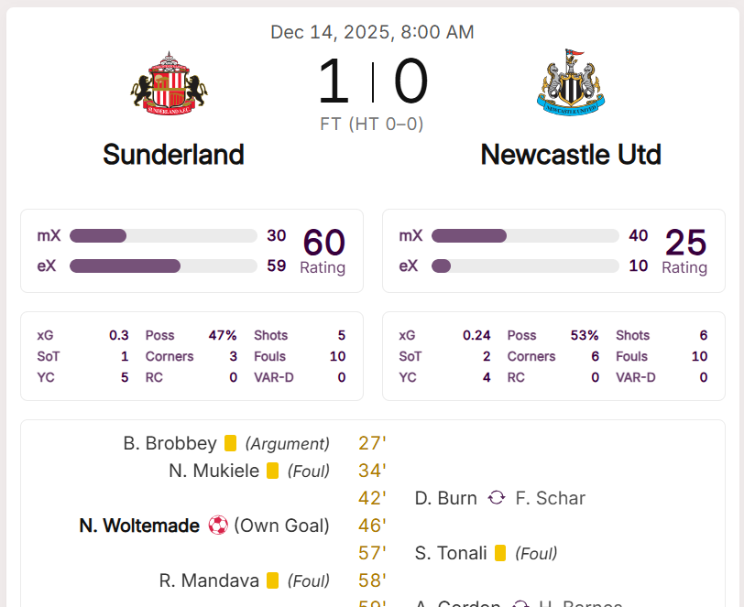

Sunderland gets “full” credit for own goal – uh uh
